**Mid-Term Project Report**

**Metabolic Transport and Cooperation**

There exists great variability among microbial communities, both genetically and metabolically. Microbial communities modify their environments by virtue of their metabolic activities continuously modifying the ecological interactions. (fitness paper). The ecological interactions among communities can be classified on the basis of net fitness effects on the organisms involved and ranges from antagonistic (negative fitness consequences), neutral (no net consequences) to beneficial interactions (positive fitness consequences). Some commonly encountered antagonistic examples include release of toxins like colicins, antibiotics that inhibit the growth of other bacteria. The beneficial interaction include cooperative behaviours in which one organism produces a metabolite (termed as public good) incurring some cost to itself but is shared with other organisms genetically related or unrelated. The cooperative interaction involving kin selection and wherein the public goods are shared only with genetically related organisms is called altruistic cooperation. The interaction where metabolites are reciprocally exchanged between unrelated individuals is called synergistic interaction. Many of these interactions are obligate and the individuals can survive only in the presence of the metabolite that could be supplied by another organism (D’souza *et al.,* 2018).

1. **Cross-feeding Interactions**

The term cross-feeding was first coined by Hermann Reinheimer in 1921 who defined ‘in-feeding’ as within kingdom exchange and ‘cross-feeding’ as between kingdom exchange. The scientific community at large uses cross-feeding to describe the exchange of metabolites that is associated with enhanced growth (D’souza *et al.,* 2018).

* 1. Classification

Considering the exchange of primary metabolites, the cross-feeding interactions can be classified on the basis of degree of reciprocity and the investment made by the involved organisms.

Degree of reciprocity categorizes metabolic exchanges into unidirectional (one-way) and bidirectional (reciprocal) transfers. According to the investment made by the organisms during biosynthesis, the interaction is categorized into by-product cross-feeding and cooperative cross-feeding. By-product cross-feeding involves exchange of growth associated metabolic by-products produced as a selfish act of producer and is independent of the presence of an interacting partner. In cooperative cross-feeding, the partner organism invests its resources for the over expression of a particular metabolite for benefiting the interacting partner (D’souza *et al.,* 2018).

The five different interactions are;

1. Unidirectional by-product cross-feeding: In this type of interaction, one cell releases a metabolic by-product benefitting another individual.
2. Bidirectional by-product cross-feeding: In this type, the by-products are reciprocally exchanged between two partners.
3. By-product reciprocity: In this type, the cooperative individual produces the costly metabolite to increase the amount of by-product it obtains from its partner
4. Unidirectional cooperative cross-feeding: This is a theoretical interaction. In reality mutants that make the increased investment without being rewarded are not preferred by natural selection and have transient existence.
5. Bidirectional cooperative cross-feeding: When both the interacting partners produce a costly metabolite benefitting each other. These interactions are difficult to detect in natural microbial populations and are studied by synthetically engineering microbial species in laboratory (D’souza *et al.,* 2018).

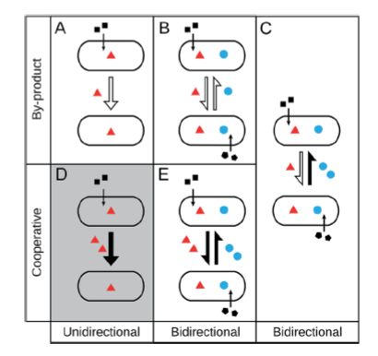

Figure 1.: Types of cross-feeding interactions (D'Souza et al., 2018)

Cross feeding interactions are studied by culture depended approaches by isolating organisms on agar plates with synthetic media containing complex ingredients to satiate the needs of difficult to culture organisms. A proof of metabolic interactions is obtained when one stain can not be cultured in the absence of the other. Application of meta-omics approaches like whole genome sequencing, annotation and hybridization techniques enable the study of strains that are non-cultivable.

Meta-analysis results show that metabolic interactions are very common in nature among bacteria, archaea, fungi, protists, plants and animals. Nature of metabolites exchanged depends on the type of partner bacteria interact with. For example, bacteria supply nitrogen, amino acids and vitamins to their hosts in exchange of assimilated carbon, shelter etc. (D’souza *et al.,* 2018).

* 1. Mechanisms of metabolite transfer

Bacteria use different contact depended and independent mechanisms to transfer materials from one cell to another by virtue of their lifestyles and structural variability of metabolites synthesised. Bacterial lifestyles include being associated with biofilms, living as planktonic cells, endosymbionts, free bacteria.

Using contact independent mechanisms, the metabolites are released intentionally or unintentionally into the external environment. It will serve as a public good or can be targeted towards a specific recipient based on the mechanism of transport.

Passive diffusion: Passage of molecules across the cell membrane along the concentration gradient without use of ATP. Usually involves small molecules like hydrogen, formate, acetate, vitamins etc. that are released as result of overflow metabolism.

Active transport: Molecules that are unable to cross the membrane due to their size, charge or polarity and are therefore transported across the membrane in an energy dependent manner using ATP. Examples include some amino acids, enzymes, polymers like proteins, siderophores, vitamins etc.

Vesicle mediated transport: Membrane vesicles are small spherical encapsulations formed via protrusions and subsequent pinching off of the outer membrane. These carry proteins, nucleic acids, enzymes and signalling molecules protecting the molecules from external environment. Some of the constituents of the vesicles are known to promote growth of other bacteria in a marine ecosystem.

Contact dependent mechanisms shuttle materials from one cell to another by establishing physical contact with the recipient cell or by making specialized structures for the same. Although the organism incurs energy cost for making these structures, it helps cater to a specific interacting partner and not serve the metabolites as public goods.

Vesicle chains: Outer membrane vesicles are used as conduits forming vesicle chains to establish an intercellular network for material transfer. *Myxococcus xanthus*, a predator bacteria link multiple individual membrane vesicles together to from the vesicle chains.

Nanotubes: These can be used to shuttle cytoplasmic proteins and plasmid DNA to cells of same or different bacterial species. For example, nanotubes are observed to transport essential amino acids between *E.coli* auxotrophs when cultured together.

Flagella like filaments: Metabolic transport can be established by existing structures. Co-culturing experiments of *Pelotomaculum thermopropionicum* and *Methanothermobacter thermautotrophicus* have shown use of flagella to transfer hydrogen. It was observed that flagellin induced up-regulation of enzymes involved in biosynthesis.

Cell-cell contact: Synthesis of specialized structures presents significant cost to the organism especially in nutrient limited conditions. This problem is overcome by direct membrane contact in multicellular aggregates where cells are closer.

Intimate cell contact between the green sulfur bacterium *Prosthecochloris aestaurii*, a photoautotroph and *Geobacter sulfurreducens*, a heterotroph satisfies the requirement of electron donor needed for the former’s growth.

1. **Evolution of cross feeding interactions**

The cross-feeding interactions, especially for the transfer of essential growth associated products, require investment to be made by the interacting cells for overproduction of the particular metabolite. Cost is also incurred for the formation of specialized structures needed for the transport of the metabolites. All the investments benefit different organisms and is not preferred by natural selection that propagates strains of organisms having fitter traits requiring less energy and resource investment and growing at the expense of others. In cooperative interactions this would mean that the organism reaps benefits of cooperation without reciprocating. On the long run the exploitation of the public goods translates to extinction for the cooperating genotypes. Despite the tragedy of commons and fitness advantage conferred to non-cooperators, the cross-feeding interactions widely observed in nature. The question to be addressed is the reason for the existence of such interactions among microbial communities, wherein an organism gives up its autonomy and relies on neighbours to derive essential metabolites. Before discussing the approaches to study the benefits of such interactions, it must be considered that the dynamics of the interactions are affected by different levels of biological organizations and the ecological environment (D’souza *et al.,* 2018). Some of these factors are discussed below.

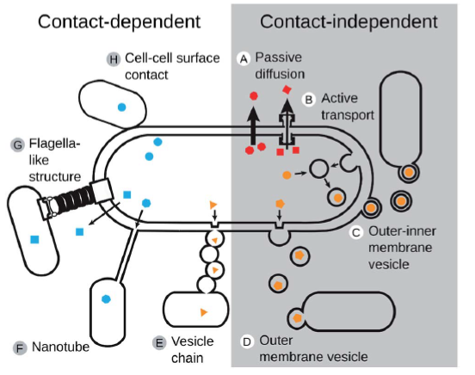

Figure 2. Mechanisms of metabolite transfer (D'Souza et al., 2018)

Cross feeding interactions are affected by the mode of function and regulation of different enzymes involved in the biosynthesis of exchange metabolites, the cellular allocation of limited resources (e.g. nutrients, expression machinery, space) to the cellular functions that are required for the cross-feeding interaction, as well as the biotic composition of the bacterial community that determines the frequency of potential producers and consumers of exchanged metabolites. Diffusibility of chemicals, availability of nutrients and degree of spatial structuring are the environmental conditions that influence the evolutionary fate of these interactions (D’souza *et al.,* 2018).

Performing a biosynthetic function consumes resources that become unavailable to other cellular processes. Absence of a particular function can result in reallocation of resources to some other pathway. Metabolic flux distribution can be studied to estimate the cost for a particular biosynthetic reaction. The metabolite production cost is influenced by the structure of the metabolic network. Other factors that affect the production cost are the substrate preference of a particular species and spatial structure of the community. A heterogeneous distribution of nutrients leads to unequal access among the communities. The During metabolic division of labour, a one partner overexpresses a metabolite, while another co-operator expresses another. On comparing the costs incurred during autonomous production with that incurred during division of labour, if the energy saved is lesser in the latter, the cooperative interactions get evolutionary preference. Trading of metabolites may therefore allow bacteria to increase resource efficiency by segregating the conflicting pathways into separate cells (D’souza *et al.,* 2018).

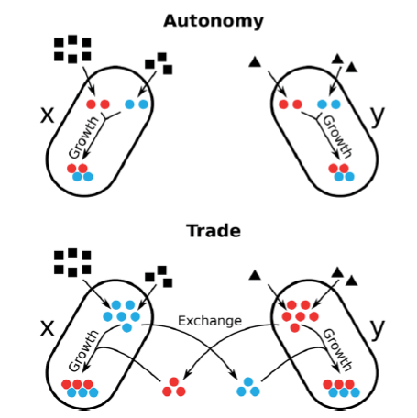

Figure 3. Economics of microbial metabolic trade and the role of comparative advantages (D'Souza et al., 2018)

While the above points discuss the fitness benefits of the cross-feeding interactions, they do not explain the evolution of these interactions in an isolated population of non-cooperating cells.

Metabolic leakage can be considered as the first step towards evolution of metabolic interactions. Many biochemical functions are leaky meaning the products are released into the external environment making them available to the neighbouring cells who can take advantage of the released resources saving the costs for producing these themselves. This leads to evolution of unidirectional by-product cross feeding interaction.

Obligate metabolic interactions can evolve through the mutational loss of a conditionally essential biosynthetic genes producing auxotrophs in the population with reduced genome sizes. This process is called genome streamlining. Shutting down the endogenous machinery thereby saves the associated energy costs, ribosome costs, protein and carbon costs. The loss of metabolic genes confers a fitness advantage on the cells when the nutrients are available in the external environment. The trait also gets fixed by random genetic drift occurring in a small population.

By-product reciprocity interactions get fixed when one organism producing the costly metabolite overexpresses that simultaneously enhances the growth of the dependent organism which then supplies more of its by-products to the cooperating organism. levels. This automatic feed-back therefore not only stabilizes the costly cooperative investment, but also paves the way for the evolution of reciprocal cooperative cross-feeding interactions.

Cooperators and non-cooperators have equal probability to access public goods. However, natural selection predicts dominance of the non-cooperating genotypes leading to the collapse of the cooperating types. Therefore, appropriate steps that ensures exchange of metabolites among the co-operators need to be implemented. These mechanisms increase the probability of cooperative phenotypes interacting with co-operators and decrease the chance of encountering non-cooperators, a concept called positive assortment. Positive assortment can be achieved by physical localisation to increase the probability of interactions among the co-operators (partner fidelity) and by partner choice, that facilitates the localization and association of the partners or antagonizes the non-co-operators.

**Previous Studies**

Pande *et al.,* (2014) investigated the fitness consequences resulting from the splitting of metabolic functions among two genotypes and the vulnerability of co-operators cross feeding interactions to exploitation by non-co-operators. The study involved genetically engineering *E.coli* to characterise obligate dependency of both partners and to determine the cost of metabolite over-production. The interaction based on reciprocal exchange of amino acids synthesised by the two strains was studied. They observed an amino acid production levels that was four times higher in cross feeding strains than that seen in single gene deletion mutants. The cross feeding consortia could persist in the presence of non-cooperators-wild type and auxotrophs. The competitive assay experiment showed that the cross-feeding consortia has a stronger ability to invade auxotrophs. Their results provide evidence for a significant fitness advantage of obligate cross-feeding relative to metabolic autonomy and suggest that the metabolic cross-feeding interactions can stably coexist with other, noncooperating genotypes, even in the absence of spatial structure.

Estrela *et al*., (2016) studied the drivers of metabolic interdependencies and explored the reasons of losing function that makes an organism dependent on other organisms. They modelled the effect of privatization level, cost incurred and essentiality of functions on the interaction between organisms. It was found that mutual interdependency was favoured at intermediate levels of privatization, one-way dependency at low levels of privatization when loss of function benefits increased.

Synthetically engineered *E.coli* auxotrophic for leucine and lysine production were investigated for cooperative interactions. Adaptive evolution of the auxotrophs yielded enhanced growth rate. Increase in growth rates was also achieved in co-culture using independently evolved strains, however the community structure differed in both the experiments. It was observed that the evolved auxotrophs showed a higher growth rate in co-culture, while the rates decreased when grown as mono-cultures (Zhang *et al*., 2014).

The experimental studies are conducted in a laboratory using genetically engineered strains that are cultured on synthetic media. The composition of these are different from the natural ecosystems. The dynamics of various biological parameters (metabolic factors) influencing the interactions also vary under in-vitro conditions.

**Question definition and Approach**

Section 2 describes the probable reasons for the evolution and persistence of cross-feeding interactions in natural ecosystems, despite natural selection routing for the dominance of non-co-operators for the increased fitness benefits owing to the economic utilization of resources. The objective is to understand the fitness associated with these interactions by determining

1. Fitness associated with overproduction of enzymes catalysing two consecutive steps in a biosynthetic reaction by the partners of a cooperative cross feeding interaction. Comparing the cost incurred by the biosynthesis function in a prototroph and two cooperating auxotrophs (assuming a nutrient limited environment).
2. Optimum amount of resources required for functioning of a prototroph, an overproducer and an auxotroph. Studying the fitness associated in a biosynthetic pathway with n (say 3) number of metabolites.

**References**

D'Souza, G., Shitut, S., Preussger, D., Yousif, G., Waschina, S., & Kost, C. (2018). Ecology and evolution of metabolic cross-feeding interactions in bacteria. *Natural Product Reports*, *35*(5), 455-488.

Estrela, S., Morris, J. J., & Kerr, B. (2016). Private benefits and metabolic conflicts shape the emergence of microbial interdependencies. *Environmental microbiology*, *18*(5), 1415-1427.

Pande, S., Merker, H., Bohl, K., Reichelt, M., Schuster, S., De Figueiredo, L. F., ... & Kost, C. (2014). Fitness and stability of obligate cross-feeding interactions that emerge upon gene loss in bacteria. *The ISME journal*, *8*(5), 953.

Zhang, X., & Reed, J. L. (2014). Adaptive evolution of synthetic cooperating communities improves growth performance. *PloS one*, *9*(10), e108297.

Submitted by:

Krishna Nair

184020010